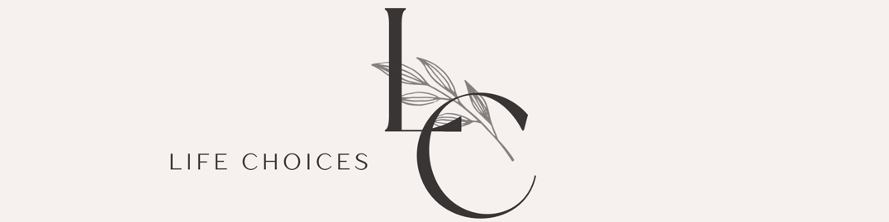

Life Choices Pregnancy Resource Center
230 E 22nd Street Suite 2 Fremont, NE 68025
402.721.5551 24/7 nurse text line: 402.961.7148
Email: lifechoicesfremont@gmail.com
Website: www.fremontpregnancy.com
T, W, Th l0AM-5 PM

New Items

Baby & Toddler Supplies

- Diapers (especially sizes 4, 5)
- Pull- ups
- Wipes
- Diaper rash cream
- Baby shampoo, wash, lotion
- Baby combs/brushes
- Baby bottles, nipples, bottle brushes
- Sippy cups
- Children's toothpaste and toothbrushes
- Pacifiers
- $10 gift cards to local businesses- for Parenting Class completion incentives. (Casey’s, Walmart, Dollar General, etc.)
- Nursing pads

Center Supplies

- Paper towels
- Hand soap
- Toilet paper
- Disinfectant wipes
- Gallon Ziplock type bags
- Copier paper
- Staples gift cards – for newsletter printing
- Bottled water

Gently Used

Only items in good condition, please

- Children's clothing: baby to 2T sizes
- All baby items
- Toys
- Blankets
- Large items ie strollers, bassinets, etc
- Breast pumps (no used pump accessories}

Monetary Gifts
- Cash/check donations
- Donate online via our website: www.fremontpregnancy.com
- Amazon or Walmart Gift cards

Not Accepted

- Stained, dirty items
- Adult clothing & shoes
- Household items & furniture
- Used undergarments
- Breast pump accessories

